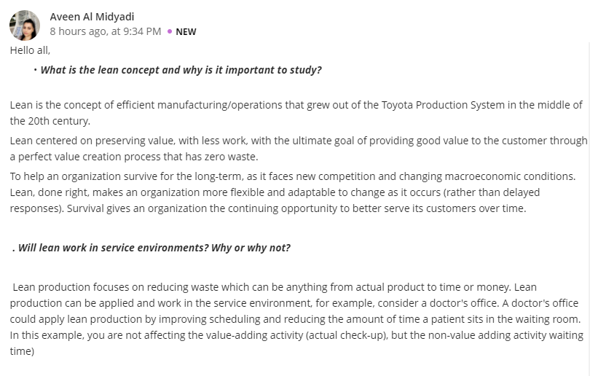Reply 1
Lean is a concept responsible for maximizing customers' values while minimizing waste during the production process. The idea originated out of the Toyota production system in the 20th century. Therefore, the main reason for studying the lean concept is to learn how to optimize people, resources, efforts, and the firm's energy toward developing value for the consumers. Studying the lean concept is also essential since it promotes continuous improvement of the organization and respect for the clients.
According to me the answer is yes, lean can work in a service environment. This is because lean is a method that is comprised of a set of tools and techniques designed to ensure customer value is maximized while minimizing waste in the production chain. Time is a critical factor in lean production, and it is what determines an organization delivers the level of quality service. For instance, service at the pizza restaurant.
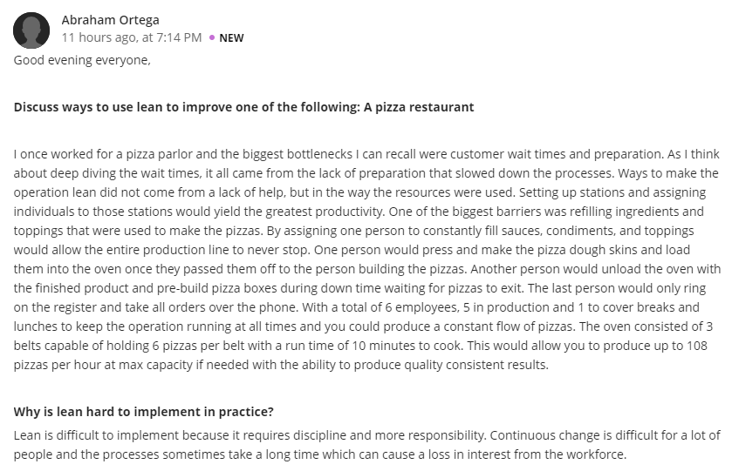Reply 2
The lean concept can be applied to improve pizza restaurant in many ways. First, lean helps eliminate defects in the production and reduces waste; hence this leads to customer satisfaction by creating a consistent product that can be served to consumers as fast as possible. Also, lean can help improve pizza restaurant by creating a way of improving order times and accuracy in both production and delivery of pizzas to customers.
Lean proves to be hard to implement in practice because it needs patience, discipline, and total responsibility. Also, lean's changes are gradual, making employees lose hope in it since most individuals tend to find continuous change to be more difficult.

